Objectives:

* Using the IF Block Structure
* Using the Write and Read methods
* **There are FIVE challenge exercises, each worth 20%**

Please submit this document for grading when completed… Please work in-groups.

Note: turn on the line numbers by following these steps on the Visual Studio IDE. Click on tools >> options >> expand the text editor >> expand python >> click general >> choose line numbers

**Project #1** (using decision structures in python) this program will get the average of three numbers and if the average is greater than or equal to 95 prints congrats! else print try harder

**Project #2** (using the if, elif, and else statements)

We use these statements to ensure the program can make certain decisions. There can only be one true statement in an If block structure.

Now, let’s write to a file and read from it. Type the following below, after the else statement. This will write and read from the projects default directory.

Here we are declaring the f as a variable and appending the data by using the “a” for append. Then we read the data after it is written on the console. Notice, we use the “r” for read.

Here is an example writing to a specific directory

Notice, that if the average is over 100, the program will automatically- execute the else statement. See example below. The average is 200 which is over 100 but assigned an F letter grade. This is because the IF block structure is only comparing 0-100

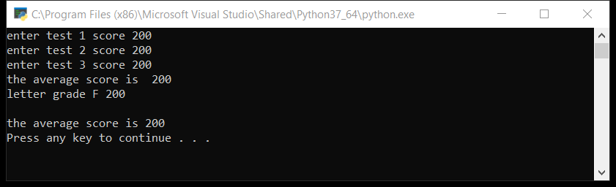

**Challenge Exercise #1:** modify/add to the program that if the average is greater then 100 then print “the average cannot be over 100, try again”

**#1 type three test scores that will exceed the average over 100 and print screen the output with code below here.**

**Challenge Exercise #2:** write a program using the decision structure using the diagram below

**#2 Print screen the code with results below here.**

**Challenge Exercise #3:** write a program based on the following diagram below.

**#3 Print screen the code with results below here.**

**Project #3** (using decision structure to get the gross pay).

Sample output

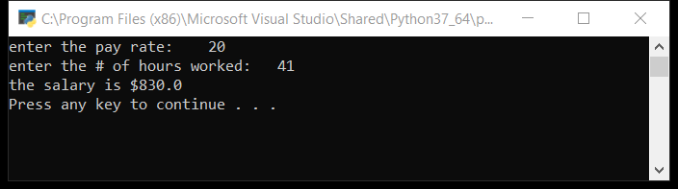

**Project #4** (Day of the week program)

**Project #5** (Age Classifier)

Write a program that asks the user to enter a person’s age. The program should display a message indicating whether the person is an infant, a child, a teen, or an adult.

Following are the guidelines:

* If the person is 1 year old or less, he or she is an infant
* If the person is older than 1 year, but younger than 13 years, he or she is a child
* If the person is at least 13 years old, but less than 20 years old, he or she is a teen
* If the person is at least 20 years old, he or she is an adult

**Challenge Exercise #4:** Complete the following program using an IF block structure.

**#4 Print screen the code with results below here.**

**Challenge Exercise #5:** Complete the following program using an IF block structure.

**Submit this document to Module 2 Class Exercise #2**